# ECE 385

Spring 2024

Experiment # 5

# Lab5 : An 8-bit Multiplier in SV

Name:Jie Wang, Shitian Yang

Student ID: 3200112404, 3200112415

Prof. Chushan Li, Prof. Zuofu Cheng

ZJU-UIUC Institute

March 15, 2024, Friday D-225

TA: Jiebang Xia

Demo Point: 4/5

## 1.Introduction

In Lab 5, we enter the heart of digital arithmetic by designing and implementing an 8-bit multiplier using SystemVerilog. This lab exercise not only underscores the fundamental principles of multiplication algorithms but also showcases the power of hardware description languages in modeling and simulating digital circuits. By comparing the implemented algorithm to traditional multiplication methods, we gain valuable insights into the efficiencies and challenges of digital system design, preparing us for more complex engineering tasks ahead.

## 2.Prelab Question

### 1. Calculate the Switched Multiplier & Multiplicand:

Q: S*B = ? S = -5910 = 110001012  ; B = 710 = 000001112

|  |  |  |  |  |  |
| --- | --- | --- | --- | --- | --- |
| function | X | A | B | M | Comments for the next step |
| Clr_A_ld_B | 0 | 00000000 | 00000111 | 1 | M=1, add S to A |
| ADD | 1 | 11000101 | 00000111 | 1 | A’s largest bit is 1, X=1, A_shift_in=1 |
| SHIFT | 1 | 11100010 | 10000011 | 1 | M=1, add S to A |
| ADD | 1 | 10100111 | 10000011 | 1 | A’s largest bit is 1, X=1, A_shift_in=1 |
| SHIFT | 1 | 11010011 | 11000001 | 1 | M=1, add S to A |
| ADD | 1 | 10011000 | 11000001 | 1 | A’s largest bit is 1, X=1, A_shift_in=1 |
| SHIFT | 1 | 11001100 | 01100000 | 0 | M=0, just shift. X=1, A_shift_in=1 |
| SHIFT | 1 | 11100110 | 00110000 | 0 | M=0, just shift. X=1, A_shift_in=1 |
| SHIFT | 1 | 11110011 | 00011000 | 0 | M=0, just shift. X=1, A_shift_in=1 |
| SHIFT | 1 | 11111001 | 10001100 | 0 | M=0, just shift. X=1, A_shift_in=1 |
| SHIFT | 1 | 11111100 | 11000110 | 0 | M=0, just shift. X=1, A_shift_in=1 |
| SHIFT | 1 | 11111110 | 01100011 | 1 | M=0, just shift. X=1, A_shift_in=1 |

**Table-1:** Calculating Process

### 2. Design the 8-bit multiplier in SystemVerilog:

As there are no template for the Lab5, we directly utilize our code from Lab4, and we modified the SystemVerilog code for key modules including ***`Control.sv`***, ***`adder_sub.sv `,`counter.sv` and `lab5_toplevel.sv `***. We then integrated an existing ***`testbench_8.sv`*** file, ensuring it was fully compatible with our 8-bit multiplier. Our modifications were compiled and subjected to simulation, which we completed successfully with no errors, confirming the functional correctness of our updates. 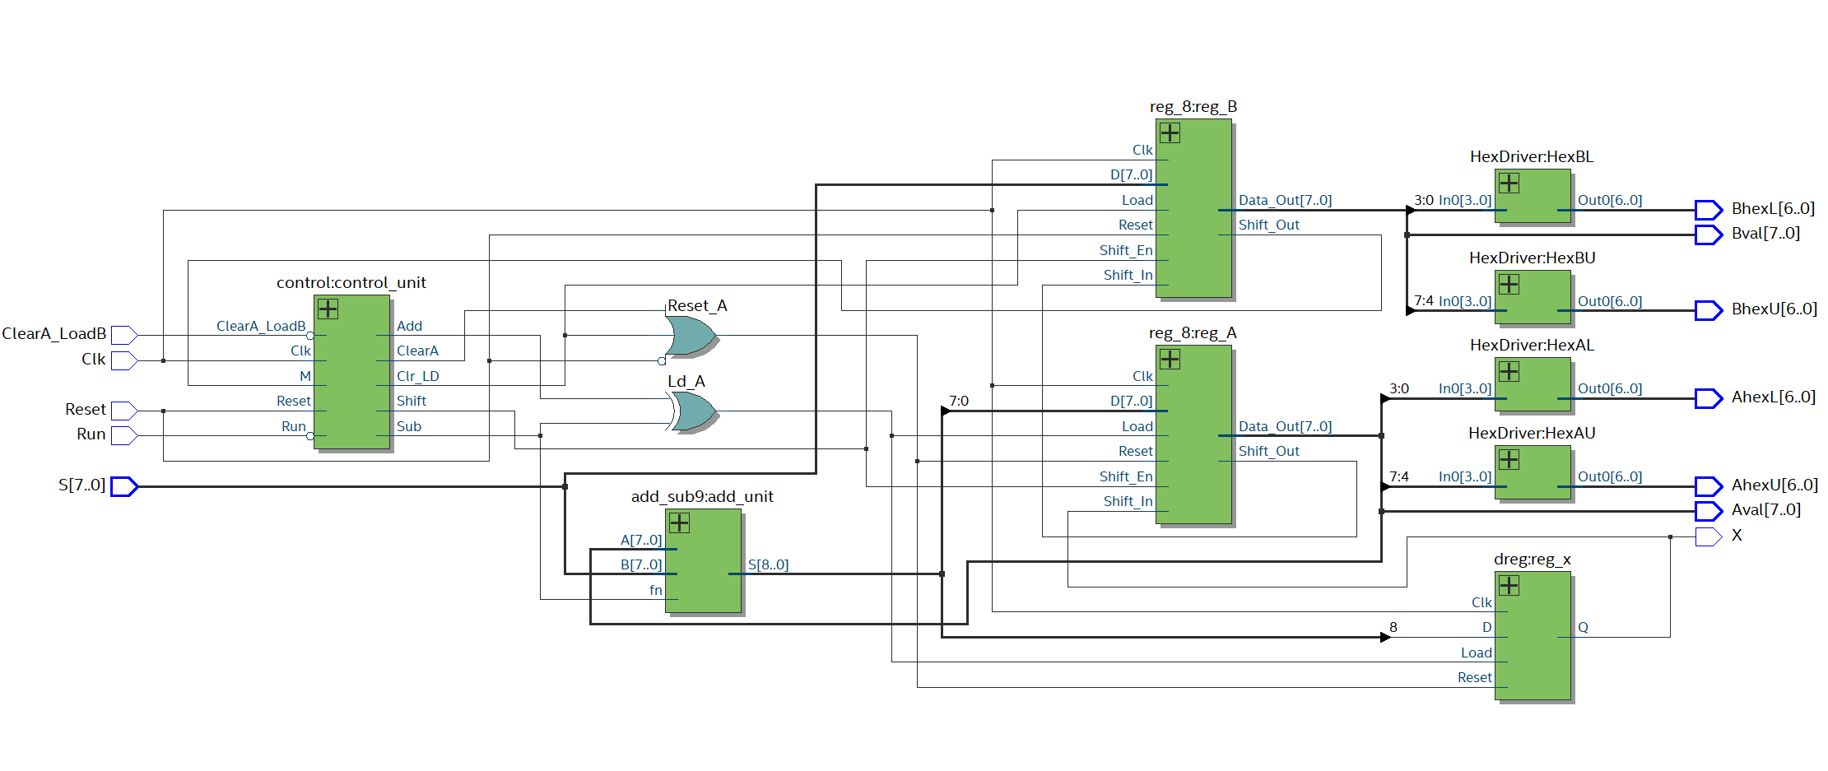

**Fig-1:** RTL Viewer of Our Circuit

## 2. Implement the 8-bit multiplier

### Adder_8bits_with_Subtract

#### 1.Description:

This module implements an 8-bit adder that can also perform subtraction through the addition of the two's complement of the second operand. It leverages the full_adder_8bits module for the core addition operation and adjusts the second operand and carry-in based on the subtraction flag.

#### 2.Description of the Operation:

The module adjusts the second operand, b, by XORing it with a mask generated by replicating the subtract flag 8 times. This effectively negates b if subtraction is required. It then sets the carry-in (b_cin) to the value of the subtract flag, effectively adding 1 in case of subtraction, thus completing the two's complement operation. The full_adder_8bits module is used to add a to the adjusted b (b_adjusted), with b_cin as the initial carry-in. This results in either addition or subtraction based on the subtract flag.

#### 3.Features:

The module supports both addition and subtraction operations on 8-bit operands. This dual functionality is achieved through a simple yet effective method of operand adjustment, enabling the reuse of the addition logic for subtraction by applying the two's complement principle.

**Inputs/Outputs:**

Inputs: a[7:0], b[7:0], subtract

Outputs: result[8:0], carry_out

#### 4. RTL View

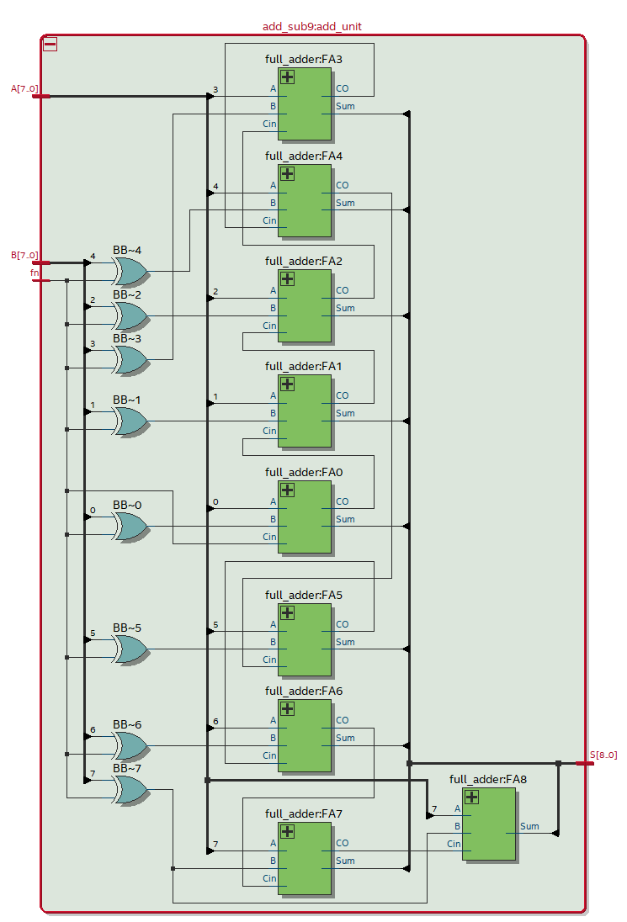

#### 5.Purpose and Operation of Each Module

##### 1)Module: full_adder_8bits

###### Purpose:

Performs 8-bit binary addition between two operands, a and b, along with an input carry (cin). It constructs the sum bit by bit and computes the final carry out.

###### Operation:

Uses a series of full_adder modules to perform bit-wise addition across all 8 bits of a and b.

Each full_adder module computes the sum and carry out for its respective bit position, with the carry out chained to the next more significant bit's carry in.

The sum (s) and final carry out (cout) are then available as outputs, representing the 8-bit sum and the overflow/carry-out respectively.

**Inputs/Outputs:**

Inputs: a[7:0], b[7:0], cin

Outputs: s[7:0], cout

##### 2)Module: full_adder

###### Purpose:

A fundamental building block used to add two single bits along with a carry-in, producing a sum and a carry-out. This module is instantiated multiple times within full_adder_8bits to construct a bit-wise adder.

###### Operation:

Calculates the sum (s) as the XOR of inputs x, y, and cin.

Determines the carry out (cout) based on whether at least two of the three inputs are 1.

###### Inputs/Outputs:

Inputs: x, y, cin

Outputs: s, cout

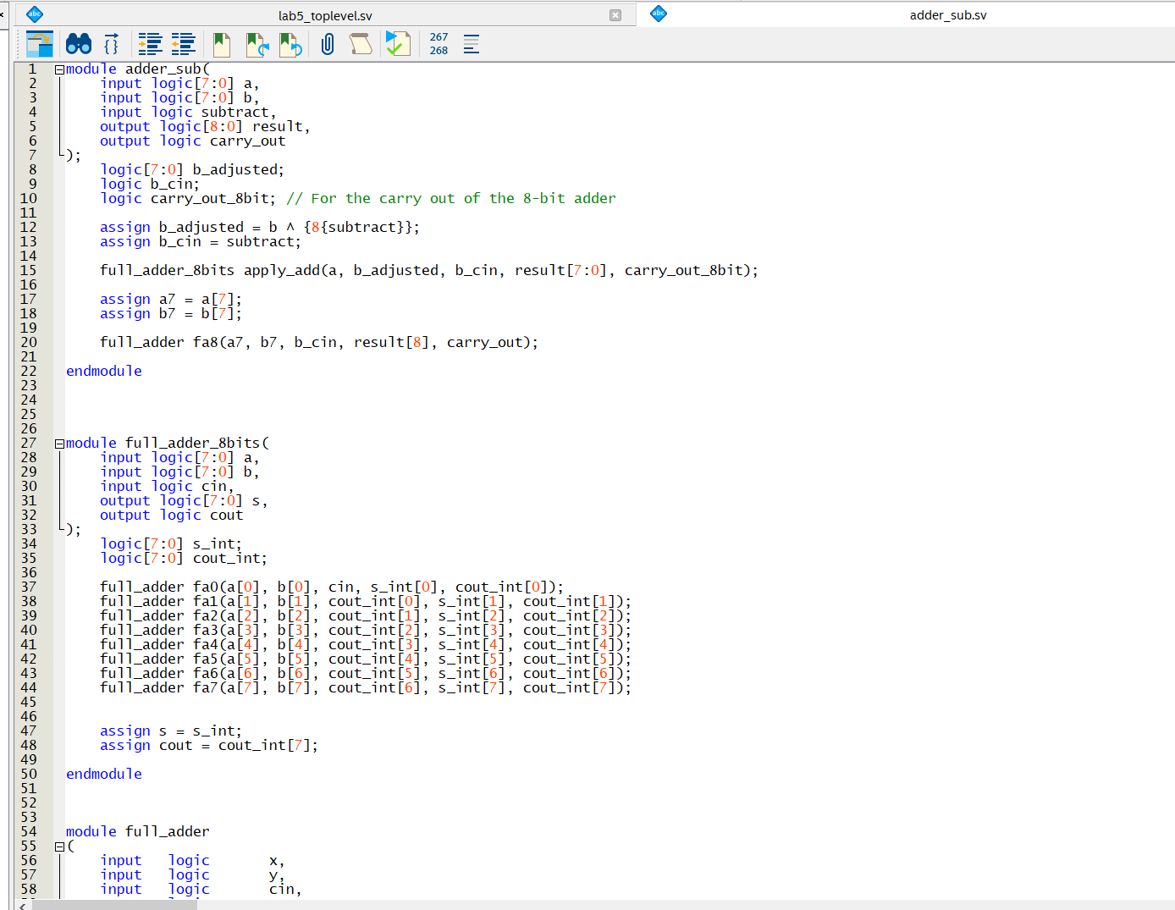

### 2. Control Unit

### 1.Description:

This SystemVerilog design comprises several interconnected modules aimed at managing arithmetic operations within a digital system. Central to the design is a state machine that interacts with control logic to determine the execution of addition, subtraction, shifting, and load/clear operations based on various input signals. This setup is particularly suited for implementing arithmetic algorithms in hardware, such as those found in digital signal processing or arithmetic logic units (ALUs).

### 2.Description of the Operation:

The operation begins with the control module, which manages the overall process flow based on input signals like Clk (Clock), Reset, ClearA_LoadB, Run, and M. This module uses internal state control logic to generate signals for clearing/loading, shifting, adding, and subtracting.

A 5-bit counter is employed within the control_with_counter module to execute specific actions at different counts, such as performing subtraction when a certain count is reached or deciding when to shift or add based on the counter's current state.

***The dreg_control module*** is a simple D-type register used for holding the state of control signals, ensuring that operations like load, add, and subtract are executed only when appropriate conditions are met.

### 3.Features:

* **Modular Design:** The design is highly modular, with clear separations of concerns among different functionalities. This makes the design scalable and easy to debug or extend.
* **State-Controlled Execution:** It leverages state machines for controlling the execution flow, making it robust and flexible for various arithmetic operations.
* **Versatility in Operations:** The design supports a range of arithmetic operations including addition, subtraction, and shifting, making it suitable for a wide array of arithmetic processing tasks.

### 4. RTL View

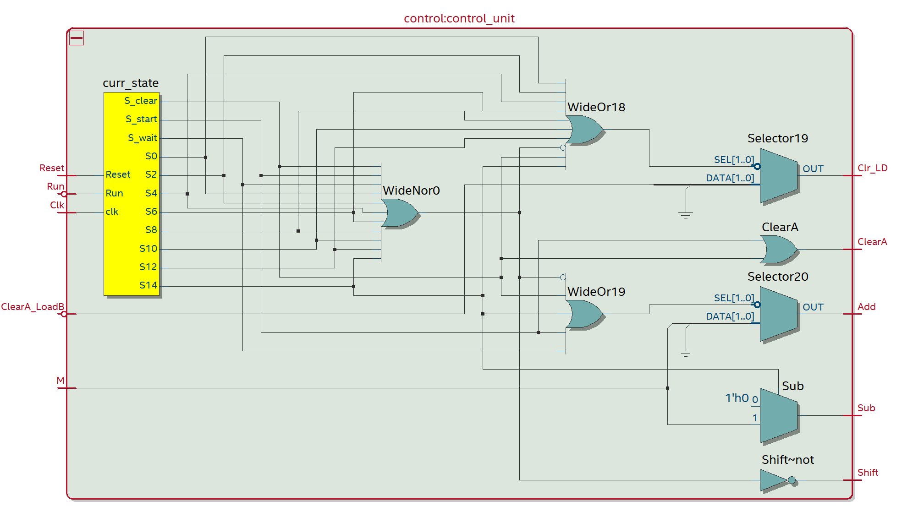

### Purpose and Operation of Each Module

#### (1)Module: control

##### Purpose:

Serves as the main control logic unit for a digital system, managing the execution of operations like load/clear, shift, add, and subtract based on the system state and input signals.

##### Operation:

Manages system states through a sequence of control signals derived from input conditions and internal logic. Utilizes dreg_control modules to hold and transition states based on Run and ClearA_LoadB inputs. Controls the arithmetic and data manipulation operations by generating appropriate control signals (Clr_LD, ClearA, Shift, Add, Sub) to other system components.

##### Inputs/Outputs:

Inputs: Clk, Reset, ClearA_LoadB, Run, M

Outputs: Clr_LD, ClearA, Shift, Add, Sub

#### (2)Module: dreg_control

##### Purpose:

A digital register (D-type flip-flop) designed to hold a single bit of data, used within control logic to maintain the state of a control signal over time.

##### Operation:

Holds a 1 or 0 state based on the Run input signal, allowing for simple state transitions in control logic.Resets to 0 when a high signal is received on the Reset input, ensuring the system can return to a known state.

##### Inputs/Outputs:

Inputs: Clk (Clock), Reset, Run

Outputs: Data_out (The current state of the control signal)

#### (3)Module: control_with_counter

##### Purpose:

Integrates counter logic with control operations, determining the execution of specific actions (like clear, shift, add, or subtract) based on the counter's value and input conditions.

##### Operation:

Coordinates with the counter_5_bits module to track the progression of counts and trigger actions at predetermined points. Defines default operation states and modifies them based on the count value and Run condition, effectively linking time-based events with control logic actions. Specific operations (e.g., subtraction, addition, shifting) are triggered based on the combination of count, Run, and M inputs, aligning arithmetic operations with the system's current state and requirements.

###### Inputs/Outputs:

Inputs: Clk, Reset, Run, M

Outputs: ClearA, Shift, Add, Sub

#### (4)Module: counter_5_bits

##### Purpose:

This module acts as a 5-bit binary counter, incrementing its count with each clock cycle. It is designed to output specific flags (time_15 and wait_flag) that signal particular count values for controlling subsequent logic in a larger system.

##### Operation:

Utilizes a series of full_adder modules to increment the count value on each clock pulse. Generates a time_15 flag when the count reaches 14 (binary 01110), indicating a specific timed event. The wait_flag is set when the count exceeds 15 (binary 10000), used to initiate a wait or pause in the system operation. The count is reset to 0 upon a high signal on the Reset input.

##### Inputs/Outputs:

Inputs: Clk (Clock), Reset

Outputs: count[4:0] (5-bit count value), time_15 (flag), wait_flag (flag)

### 3. Register Unit

#### 1.Description:

The SystemVerilog modules provided, register_8bits and dreg, are designed for digital storage and manipulation within a hardware design context. The register_8bits module functions as an 8-bit register capable of loading data, maintaining current state, and shifting data left under control of external signals.

#### 2.Description of the Operation:

**Reset:** Clears the register's contents to zero.

**Load Data** (Load_d): Loads an 8-bit value into the register from Data_in.

**Shift Function (Shift_function)**: Performs a left shift operation on the register's contents, introducing a new bit on the right from Left_shift_In.

**Output:** The module outputs the current stored data through Data_out and provides the bit shifted out on the left through Left_shift_Out.

#### 3.Features:

* **Versatility in Data Handling:** Capable of both storing and manipulating data, including shifting operations that are essential in many digital processing tasks. Serial Data Processing: Facilitates serial-to-parallel and parallel-to-serial conversion, useful in communication interfaces. State
* **Retention:** Maintains its state across clock cycles, allowing for persistent storage of data within a cycle-based processing environment.

#### 4. RTL View

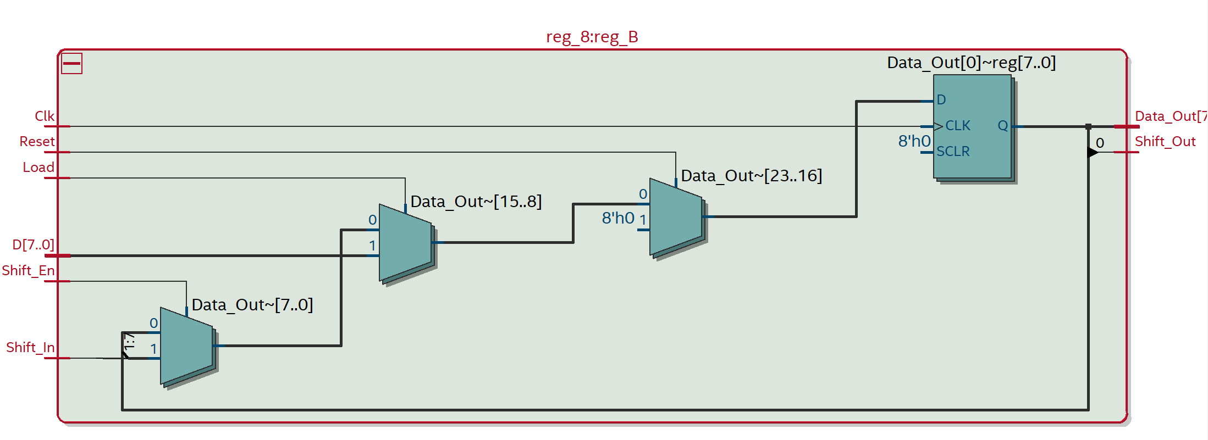

#### 4. Purpose and Operation of Each Module

##### 1)Module: register_8bits

###### Purpose:

This module is an 8-bit register designed for storing and optionally shifting its contents. It supports loading new data, holding the current data, or performing a left shift operation based on control signals. It's useful in digital designs that require temporary storage and manipulation of 8-bit wide data, such as in digital signal processing, data path units of microprocessors, or shift registers in communication interfaces.

###### Operation:

On a reset (Reset high), the module clears its contents to 0. If the Load_d signal is high during a clock edge, the module loads the 8-bit Data_in into Data_out. If Shift_function is high, the module performs a left shift operation on the next clock edge, taking Left_shift_In as the new least significant bit (LSB). This allows for serial data processing or manipulation. The leftmost bit (MSB) shifted out is available at Left_shift_Out, enabling chaining of registers or extraction of shifted-out data.

###### Inputs/Outputs:

Inputs: Clk (Clock), Reset, Left_shift_In, Load_d, Shift_function, Data_in[7:0]

Outputs: Left_shift_Out, Data_out[7:0]

Module: dreg

###### Purpose:

A simple D-type flip-flop (DFF) that stores a single bit of data. This module can be used as a building block for larger storage elements or for simple state storage in control logic. It is fundamental in digital systems for holding state, debouncing, synchronization, or simple flag/status storage.

###### Operation:

Upon a reset (Reset high), the stored bit is cleared to 0.

If Load_d is high on a clock edge, the module loads the Data_in bit into Data_out.

If neither reset nor load conditions are met, the output retains its current state, ensuring stable storage of a single bit across clock cycles.

###### Inputs/Outputs:

Inputs: Clk (Clock), Reset, Load_d, Data_in

Outputs: Data_out

TODO

1.**Description:**

2.**Description of the Operation:**

3.**Features:**

**4.** **RTL View**

**5.Purpose and Operation of Each Module**

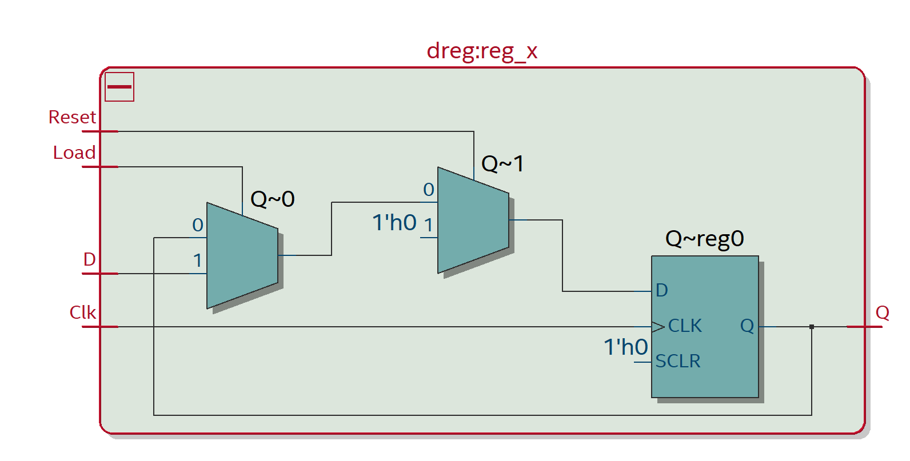

**Fig 2:** FSM Viewer Output, including 4 more state G, H, I, J

Fig-3: 0-1000ns Waveform, ErrorCnt == 0

Fig-4: Passed all the testcase in ***testbench.sv***

## 5.Post-lab Questions

### (A) Power Analysis

#### 1. Refer to the Design Resources and Statistics in IQT.30-32 and complete the following design statistics table.

|  |  |  |  |  |  |  |  |  |
| --- | --- | --- | --- | --- | --- | --- | --- | --- |
| **Feature** | **LUT** | **DSP** | **Memory**  **(BRAM)** | **Flip-Flop** | **Frequency** | **Static power** | **Dynamic Power** | **Total Power** |
| **Data** | 94 | 0 | 0 | 36 | 85.04 | 96.33 | 2.31 | 158.23 |

### (B) Question

#### 1. What is the purpose of the X register. When does the X register get set/cleared?

X is used for the first bit of A while shifting. It maintains the positive or negative result while shifting. When Clear_A_load_B is pressed, X will be cleared. And every time after add or sub function, it needs to detect the first bit of A and load this first bit to X if it is changed.

#### 2.What are the limitations of continuous multiplications? Under what circumstances will the implemented algorithm fail?

Overflow: When multiplying two numbers, the result can have twice as many bits as each operand. If the system does not accommodate for this increased bit-width, it could lead to overflow.

Speed: For larger numbers or higher bit-widths, the add-shift method can become increasingly slow and complex, as it requires multiple iterations to complete a single multiplication.

#### 3.What are the advantages (and disadvantages?) of the implemented multiplication algorithm over the pencil-and-paper method?

##### Advantages:

**Automation:** The algorithm can be fully automated and executed at a speed that manual methods cannot match.

**Accuracy:** High accuracy without the human error.

##### Disadvantages:

**Overhead for Small Calculations:** For small, one-off calculations, the setup and execution of the algorithm might introduce more overhead than simply doing the calculation by hand.

**Complexity in Implementation:** Implementing the algorithm in hardware or software requires a detailed understanding of digital systems and can be more complex than simply performing the calculation manually for a single instance.

## 6. Bug Log

- Description of all bugs encountered, and corrective measures taken:

### 1. Can not install the USB Blaster Driver

One of Jie’s Laptop is accidentally broken, and he was unable to install the USB Blaster Driver from the DE-2 board on a new device with Quartus Prime 20.1. After several attempts and discussions within the ECE385 WeChat Group, we found a solution by referring to installation guides on [Terasic]((https:/www.terasic.com.tw/wiki/Windows_encountered_a_problem_installing_the_drivers_for_your_device) and [Intel's websites](https://www.intel.com/content/www/us/en/support/programmable/support-resources/download/usb-blaster.html). This resource guided us through the correct installation process, eventually resolving our driver installation issue.

### 2. LED Digit not Functioning

Although our code passed all the test cases in ***‘test_bench.sv’***, it didn’t display correctly on the DE-2 board. After reinvestigating the specific LED pin assignment, we fixed the wrongly assigned LED, and the digit can be displayed correctly.

### 3. DE Board Cannot Load Data

We found that our toplevel file fall into an infinite loop, which disabled it from entering new data. After we fix it according to the routine in Lab Manual, it works correctly.

## 7.Conclusion

Through lab5, we practiced on the overall deployment of System Verilog together with the

performance analysis as below:

# 8. References

[1] KTTECH. (2017, January 31). ECE 385 Lab 5: An 8-bit Multiplier in SV. Retrieved from <https://kttechnology.wordpress.com/2017/02/10/ece-385lab5-an-8-bit-multiplier-in-sv/> Teaching Assistant Blog

[2] ECE385 Faculty. (n.d.). [Lab 5 description](https://learn.intl.zju.edu.cn/bbcswebdav/pid-101276-dt-content-rid-1361038_1/xid-1361038_1)

[3] ECE385 Faculty. (n.d.). [Introduction to SystemVerilog (pdf)](https://learn.intl.zju.edu.cn/bbcswebdav/pid-101280-dt-content-rid-1361044_1/xid-1361044_1)

[4] ECE385 Faculty. (n.d.). [Introduction to Quartus Prime in the lab manual.](https://learn.intl.zju.edu.cn/bbcswebdav/pid-101280-dt-content-rid-1361046_1/xid-1361046_1)